2016 Annual Program Report

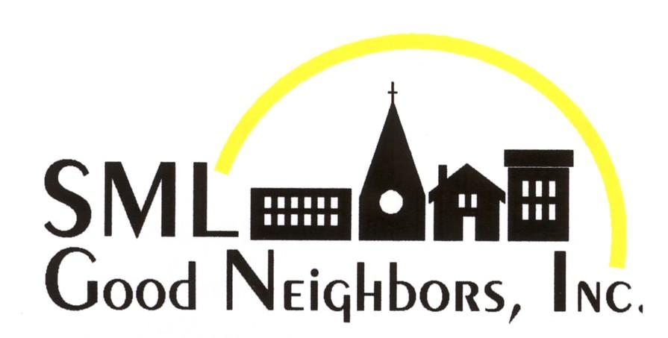

Developing good neighbors skills and values in children through programs that nourish, educate and support them while providing life-changing experiences for college students through leadership development internships.

Lisa Lietz, Program Director
Dr. Russell Baskett, Executive Director

Table of Contents
Introduction & History
Our Supporters
Board of Directors - 2016
Programs
Summer Enrichment Day Camp
Bedford County Camp
Franklin County Camp
The Middle School Academy
S.E.A. - The Student Enrichment in the Arts Program
Out-of-School Activities in Bedford County
Leadership Development “Internships” for College Students
Volunteers
The SML Good Neighbors 2016 Nutrition Program
The Weekend Backpack Program
The SML Good Neighbors Four-Week Summer Enrichment Program
Concluding Comments

Introduction & History

SML Good Neighbors is a 501(c)3 non-profit that provides academic and enrichment programs, year round in both Bedford and Franklin Counties. These programs are free of cost to families, and serve students that are rising 1st through rising 7th graders. SML Good Neighbors was founded in 2007 by a group of community members from various churches and organizations. The programs provided by SML Good Neighbors have grown substantially since the inception of its first summer feeding program in 2007 and summer enrichment day camp in 2008.

From the commencement of these two summer programs, the organization has expanded from serving 65 children, rising 1st through 4th graders at the first camp to serving 162 students, rising 1st through 6th graders at camp this past summer. Additionally, we also provide a summer and year-round middle school academy serving rising 6th through rising 8th graders (new this year), student enrichment in the arts after-school programs throughout the school year and have continued and grown the reach of our nutrition and weekend backpack program.

The growth of the programs has been in line with our mission and has come to fruition to meet the need of expanding our reach in the community and to better serve the children in the community. To meet this rapid need for growth the organization has also grown from being 100% volunteer operated to currently having 3 year-round employees; two part-time and one full time.

Our Supporters

SML Good Neighbors receives generous financial support from hundreds of loyal, individual donors. Over 150 individuals volunteer their time and experience to support the programs for the Good Neighbors children. In addition to the support of individuals, many organizations, churches, foundations and trusts provide funding that is critical in sustaining the Good Neighbors programs. We are also grateful for our partnerships with the schools, civic organizations and businesses. Partnerships not listed below include: Bedford and Franklin County Public Schools and the Roanoke Children’s Theatre.

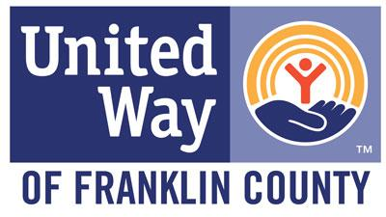

Board of Directors - 2016

Russell Baskett – President & Executive Director
Jim Bennett – Chair
Diane Burakow – Vice Chair
Rhonda Williams – Treasurer
Ann Saad – Assistant Treasurer
Cindy Decker – Secretary
Chris Brinckerhoff
Larry Broomall
Tammy Brown
Lynda Imirie
Sara Jamison
John Lietz
Melanie Simmons
Judy Wolfe

Programs

Summer Enrichment Day Camp

Our summer enrichment day camp continues to grow and flourish since its beginning in 2008. Our 9th summer of providing camp in Bedford and Franklin Counties included some new and exciting initiatives which will be described in detail below. Through assessments, family and school feedback, we know that this program has continued to be a successful and important part of our community.

Bedford County Camp

Camp was held at Moneta Elementary School through our partnerships with Bedford County Public Schools as well as our partnership on the 21st Century Community Learning Center Grant with Moneta and Huddleston Elementary Schools. Camp operates for 4-weeks from 8am to 3pm, Monday through Friday. Campers are broken into 4 classes based on age. Each week of camp focuses on a different enrichment theme for afternoon lessons. All campers enjoyed a field trip to the Smith Mountain Lake State Park during the second week of camp for experiential nature education. Rising 5th and 6th graders took additional field trips to The Phoebe Needles Center for team building activities; Booker T. National Monument to learn about gardening in the Giving and Heirloom Gardens; and, the Roanoke Rescue Mission to be of service in the community.

Students came from six public elementary schools across Bedford County as well as multiple small religious schools. Three school bus routes were used to help transport campers each day, to and from camp. Gas cards were also provided to families who needed assistance but were unable to utilize the bus routes provided. Transportation costs were funded by the Smith Mountain Lake Rotary, the 21st Century Community Learning Center Grant, SML Good Neighbors and Bedford County Public Schools. This is an increase from last year in the number of participating schools and the number of school buses. The additional transportation support allowed many students to attend camp who otherwise would not have been able to due to their transportation challenges.

We also added an additional staff member to camp this year; a special education aide, which position was partially funded through a grant from the Bedford Community Health Foundation. The purpose of this new position was to provide the resources necessary for children with individualized education plans and special needs to be able to spend more time in the classroom with their peers, rather than sitting out for behavior and social skill needs. The purpose was met and less out of class intervention was needed meaning students received more instruction and spent more time in experiential learning with their peers.

Below is a schedule outlining how each camper spends each day at camp.

8am - 9am Arrival, breakfast & morning games (all campers)
9am - 9:15am Morning songs (all campers)
9:15am - 9:30am Morning Meetings (in classrooms)
9:30am - 10am Writer’s Workshop (in classrooms)
10am - 12pm Morning rotations (Reading Buddies, Art, Gym & Flexible Activity Block [FAB]. Each class spends 30 minutes at each rotation.)
12pm - 12:30pm Lunch (all campers)
12:30pm - 1pm Supervised play
1pm - 2pm Enrichments
Week 1: Peace Education & Non-Violent Conflict Resolution.
Week 2: Nature Education (Thursday field trip to the State Park).
Week 3: Cultural Diversity & Global Education.
Week 4: Roanoke Children’s Theatre works with campers on a different theme each year. They also work with the children every Friday afternoon of camp.
2pm - 2:15pm Assessing Understanding (in classrooms)
2:15pm - 2:45pm Story Time (in classrooms)
2:45pm - 3pm Snack time and dismissal (all campers)

Bedford County Student Data:

In Bedford County, 79 Students registered for and attended camp. Regular attendance averaged 66. Of those 79 students, 63 (almost 80%) receive free or reduced meals at school. Additionally, 8 of the students had individualized education plans (IEP). Female campers account for 40, while 39 campers were male.
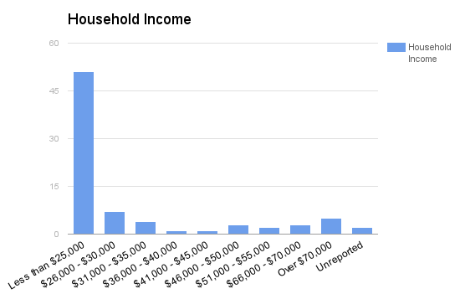

Almost 80% of campers have household incomes of less than $35,000 a year with 65% of campers having a household incomes less than $25,000 a year.

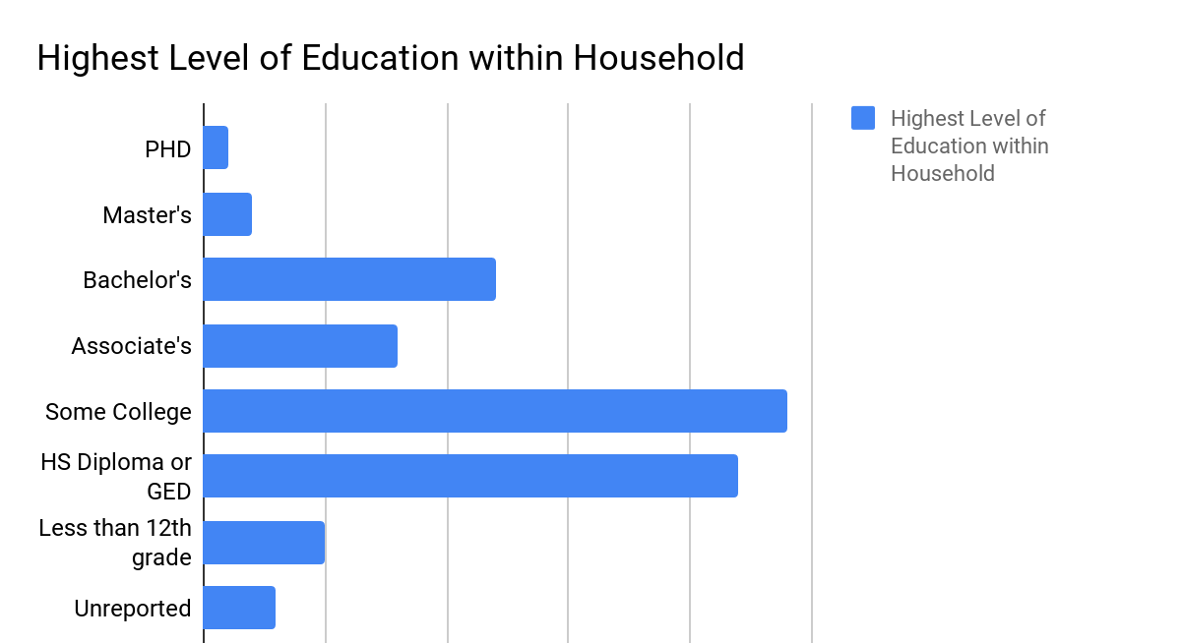

Pre and post testing is used to assess campers’ reading levels at the beginning and end of camp. The results of those assessments are presented in the chart to the left. If a camper missed pre or post testing, we were unable to report their results. It is clear that the time spent reading in a no pressure environment each day makes a difference!

Franklin County Camp

We have enjoyed a wonderful partnership with both Bedford and Franklin County Public Schools for many years. As with any healthy partnership, the relationship changes and grows over time. During the fall of 2015, representatives of Franklin County Public Schools (FCPS) and of SMLGN met to discuss the concept of integrating elementary summer school into the SMLGN’s enrichment day camp. After thorough investigation of the possibilities, a schedule and plan was presented to SMLGN’s Board of Directors and a FCPS official and was met with optimistic enthusiasm.

Facilitated by SMLGN’s camp staff, interns, volunteers, five FCPS teachers and one FCPS administrator, the summer enrichment day camp with summer school integration was successfully operated out of Burnt Chimney Elementary School June 27 through July 22, 2016.
Participating students came from six public Franklin County elementary schools as well as multiple small religious schools. Three school bus routes were used to help transport campers each day, to and from camp. Gas cards were also provided to families who needed assistance but were unable to utilize the bus routes provided. Bus transportation was provided by the Franklin County Public Schools. SMLGN provided gas cards to assist families that did not have access to bus transportation. Funding by the Smith Mountain Lake Rotary helped meet this expense. The additional bus transportation provided by FCPS allowed many students to attend camp who otherwise would not have been able to due to a lack of transportation.

Two additional staff members--a Special Education Aide and Nurse--were part of our 2016 pergram. The aide provided the resources necessary for children with individualized education plans and special needs to be able to spend more time in the classroom with their peers, rather than sitting out for behavior and social skill needs. The purpose was met and less out of class intervention was needed meaning students received more instruction and spent more time in experiential learning with their peers. The presence of a nurse provided a safer environment for our students, volunteers and staff. Knowing that we are prepared to deal with routine minor problems as well as more serious problems provides another safety net so important in programs like SML Good Neighbors.

Franklin County Student Data:

In Franklin County, 83 students registered for and attended camp. Regular attendance averaged 79. Of those 83 students, 47 (57%) receive free or reduced meals at school. Additionally, 18 of the students had individualized education plans (IEP). Female campers account for 40, while 43 campers were male.
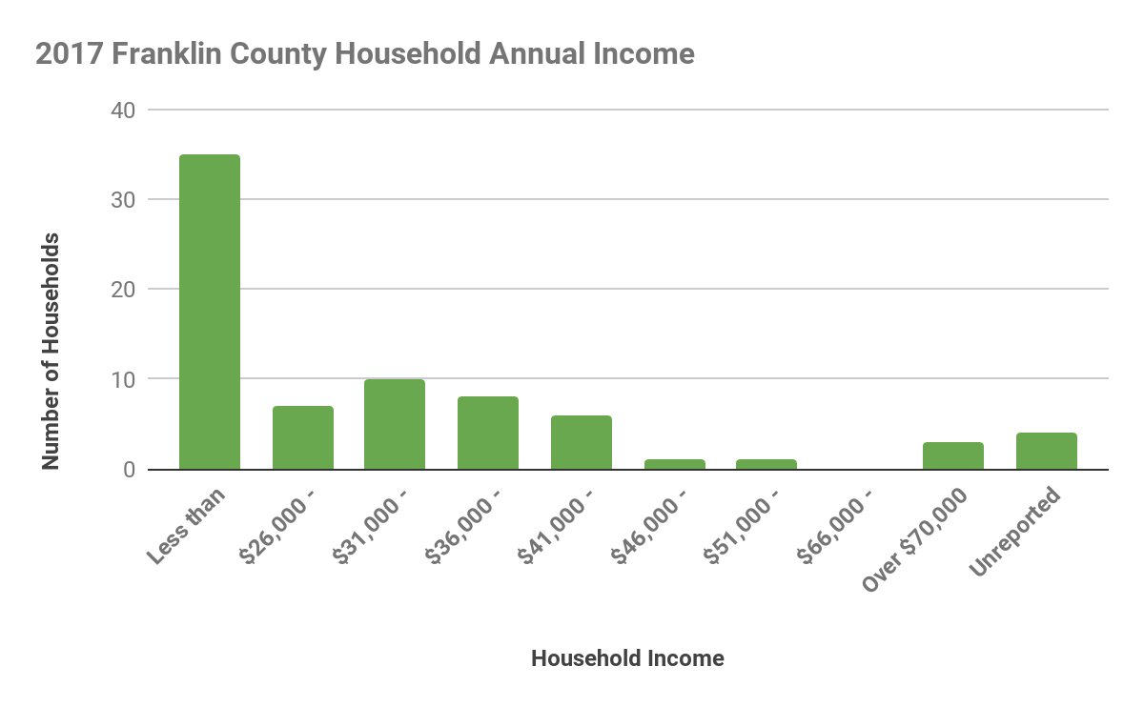
Almost 63% of the campers are from households with incomes of less than $35,000 a year with 42% of campers having a household incomes less than $25,000 a year.

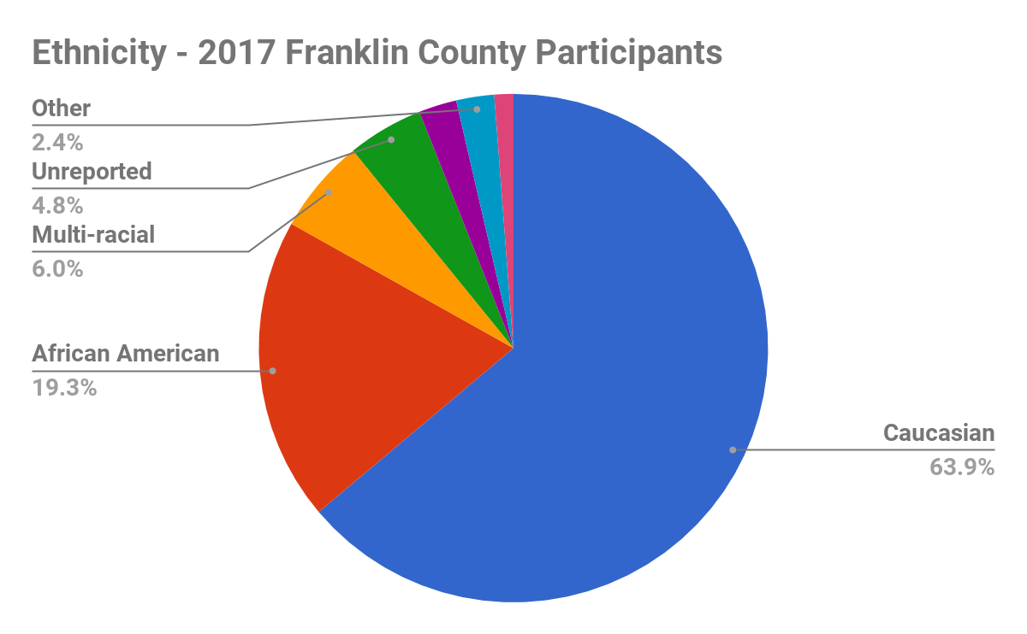
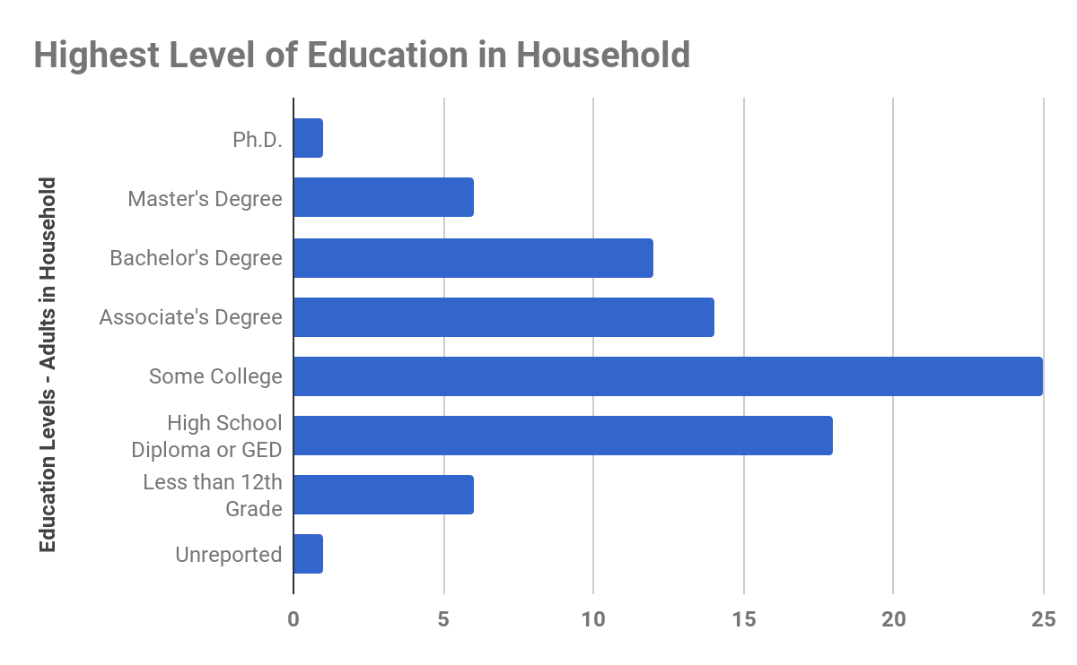

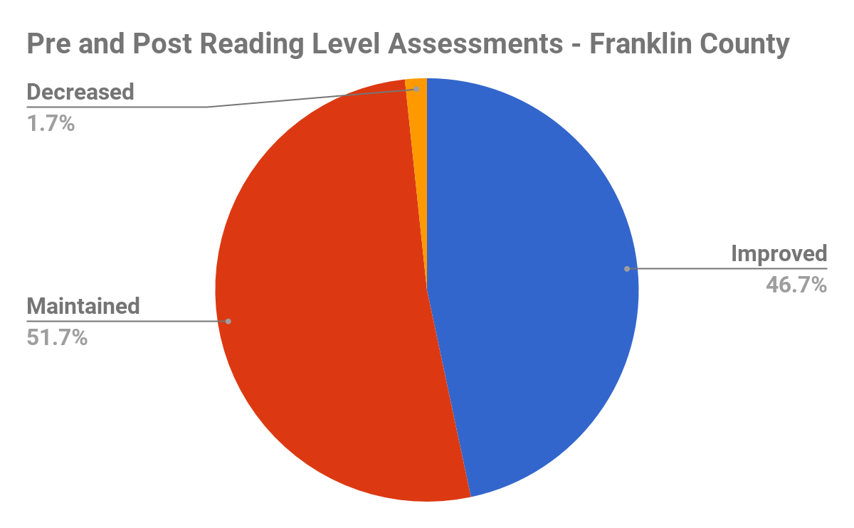
Students’ reading levels were tested at the beginning of camp and again at the end of camp to assess the impact of the four-week Summer Enrichment Program on retention or improvement of reading levels over the summer. Sixty of the 83 attending students are included in the data represented in the pie chart above. Only students that took both the pre and post tests were included. Twenty three students were not available for both tests. It is clear from the data, and consistent with results in Bedford County, that almost 99% of the students either maintained or improved their reading levels. This data verifies the impact of the SML Good Neighbors program in preventing “Summer Slide”, a problem nationwide among students that do not participate in summer programs that include reading, writing and related activities.

The Middle School Academy

A new program, The Middle School Academy, was initiated in the summer of 2016. Several years in the planning, this program serves rising 7th, 8th, and 9th graders. We determined from our experiences with younger students that a need exists for our Good Neighbors students when they age-out after 6th grade. The Middle School Academy (MSA) was planned around that need and has one primary objective - to prepare students for success in high school. The launch of this program was made possible by a generous contribution from the Wish You Well Foundation, the foundation of David and Michelle Baldacci. Additional funding came from the proceeds of concerts by the New Crusty Minstrels.

Students, and their families, understand that the MSA is a year-round program consisting of four weeks, Monday through Friday from 8 a.m. to 3 p.m., in the summer and two afternoons per week in the After-School Academy during the school year. The MSA is offered in both Bedford and Franklin Counties. The summer program in Bedford County was held at Moneta Elementary School. Six students attended and all six were present almost every day. There were four boys and two girls. The focus was on academic support and preparation for the next school year. Two summer teachers (interns) provided the instruction for these students. Both of these teachers had completed undergraduate school and were entering graduate programs in the fall. The Franklin County MSA summer program was held at Burnt Chimney Elementary School. Five students enrolled and all five attended every day. Their teachers were the same teachers that taught the Bedford County students. As in Bedford County pre and post testing in reading determined that (in both counties) one student improved their reading level and all others maintained their reading level. In both counties, as in the enrichment program for the younger students, breakfast, lunch and snacks were provided during the program. And in both counties the MSA scholars took weekly field trips to expose them to a variety of enrichments to broaden their education.

The after-school MSA program was held on Monday and Wednesday afternoons at Staunton River Middle School from September through December. Seven students participated in the Bedford County program. Nine students enrolled in the Franklin County After-School Program at the Gereau Center. They met every Tuesday and Thursday afternoon from September through December. At every session, students were assisted with homework as needed and provided additional enrichments in science, math and other subjects. They also received snacks and a simple dinner as part of the program.

The MSA had a good beginning. Or plan is to grow the program slowly over the next few years in order to meet the needs of the scholars and, working with the schools, to plan and provide programs that help prepare our students for success in high school.

S.E.A. - The Student Enrichment in the Arts Program

The S.E.A. program is an after-school program for 3rd - 5th graders in four (4) Franklin County elementary schools. The participating schools are: Sontag E.S., Rocky Mount E.S., Dudley E.S. and Burnt Chimney E.S. In 2016, a total of 83 students participated.

Students attended one afternoon per week for eight weeks at each school. In 2016 the programs were facilitated by the Roanoke Children’s Theatre. The theatre staff was assisted by volunteers and SML Good Neighbors staff. Students participate in activities that provide instruction in, and the practice of, theatre skills. These activities develop communication skills and help students see the value of team building and collaborative learning. A closing performance for family and friends was a highlight of the program for the students. Snacks were also provided at each session.

This program receives generous support from the Foundation for Roanoke Valley and the Smith Mountain Arts Council.

Out-of-School Activities in Bedford County

Three (3) Family Night programs were offered in Bedford County during the 2016 school year. These programs were supported by a 21st Century Community Learning Center grant.

- In March an evening dinner program was held at Moneta Elementary School. This program was an informational meeting for families to discuss and promote the SML Good Neighbors summer and after-school programs. 100 dinners were served at this program.

- In October an evening program for families was held at Huddleston Elementary School. In addition to providing dinner, discussions that provided tips and guidance about helping students with math at home were provided. There were 28 individuals in attendance.

- Also in October, an evening meal program for parents that focused on helping students at home with math was conducted at Moneta Elementary School. Thirty five individuals attended this program.

These programs allow SMLGN to work with families in the community, as well as their children. Connections with families are important in helping us support and nurture the children.

Leadership Development “Internships” for College Students

The primary facilitators of the Summer Enrichment Program are carefully recruited college students. The Summer Teaching Staff (interns) provide the daily planning and instruction for our students.

In 2016 we recruited 11 summer teachers. Nine of these teachers worked with rising 1st - 6th graders in the Summer Enrichment Program and two (2) with the Middle School Academy scholars. These teachers were from five (5) colleges and universities and five had worked in the program in 2015.

Volunteers

Volunteers provide critical support for all of our out-of-school programs. None of our programs could function without them. In 2016 volunteers filled many roles.

- Over 100 volunteers worked in the Summer Enrichment Program. The majority worked as Reading Buddies. Others served as Teacher Assistants, Camp Facilitators and the Moving Company (moving all teaching supplies from storage to the Bedford County teaching site, from Bedford County to the Franklin County site and from the Franklin County site back to storage at the end of the summer program.

- 15 - 20 volunteers works in the nutrition program. These volunteers gathered every Thursday morning to pack the food for the Weekend Backpack Program. The food was then delivered to the school for the students to take home every Friday during the four-week program. Weekend backpacks were also provided at two elementary schools Moneta and Huddleston) for their summer school students.

- Eight (8) volunteers served as Mentors in the after-school Middle School Academy programs at Staunton River Middle School and the Gereau Center.

- Two (2) volunteers assisted the Roanoke Children’s Theatre staff at each of the eight S.E.A. sessions. Volunteers managed check-in and check-out procedures; setup and managed snacks, including cleanup at the end of the day. And, assisted with student needs during the program.

The SML Good Neighbors 2016 Nutrition Program

The Weekend Backpack Program:

- 222 students received backpacks - 60 for two weeks and 162 for four weeks
- 4,608 meals were provided (food for six (6) meals each week)
- $7,839.58 spent on food for the program - $1.70 per meal

The SML Good Neighbors Four-Week Summer Enrichment Program

- Bedford County - in addition to Weekend Backpack food provided as described above

- 1,501 lunches served
- 950 breakfasts served
- 316 books provided in Weekend Backpacks

- Franklin County

- 1,577 lunches served
- 950 breakfasts served
- 332 books provided in Weekend Backpacks

- The S.E.A. Program

- 664 snacks served

- The After-School - Middle School Academy Program

- Bedford County -

- 126 dinners served
- 126 snacks served

- Franklin County -

- 178 dinners served
- 178 snacks served

Concluding Comments

2016 was a another year of development and growth. The Summer Enrichment Program provided the very full educational mentoring and enrichment program for rising 1st to 6th graders that is a hallmark of SML good Neighbors. Additionally, a pilot program was conducted with Franklin County Public Schools that rolled their summer school program for 48 students into the SMLGN program. This involved including five (5) FCPS teachers as part of our summer staff. The program was a success and benefitted the summer school students and the SMLGN students. Attendance was excellent and the summer school students, with minor exceptions, met the benchmarks established by FCPS in reading and math.

SMLGN launched the Middle School Academy (MSA) after several years of developing and considering several models to support rising 7th - 9th graders. The model we adopted is patterned after a very successful program - Higher Achievement. The summer Academy is four weeks in length. We did accept rising 6th graders in the 2016 program and learned that they needed a school year as 6th graders to fit in the summer program. It was concluded that 6th graders could enroll in the After-School program and then attend the following summer program as rising 7th graders. Attendance and participation in the summer program was excellent. Two summer teaching staff worked with the scholars and the program content was much more focused on academics than the program for younger students. The objective of the MSA program to to prepare students for success in the next school year. We did learn that more than two teachers are required to meet the educational needs of the scholars.This is because of the significant differences in skill levels between the students, especially in reading and math. It is recommended that two (2) additional teachers be added for the 2017 MSA Summer Program. Students and their families agree to participate in both the summer Academy program and an after-school program. In both counties, after-school MSA programs operated two afternoons each week. Each program requires a site director who is responsible for planning and facilitating activities for each session. They are assisted by two volunteer mentors. The program is flexible but includes time for homework assistance, recreation time, arts and crafts, math games and conversations with interesting people about their work or avocations. We learned a lot this first year. Among other things, we did learn that the site director does require two volunteers to effectively manage the students and provide mentoring. We also learned that there are times when behavior management is beyond the abilities of our program to control. Since we are not school, we can drop students that do not fit with our model. We also learned that the facilities we use need to have space and facilities for recreation. After a full day of school, students need outlets that are not simply more school when they arrive for the academy program. Planning for 2017 will include conversations between the site directors and the program director about the 2016 experience.

Finally, it must be said that the accident that destroyed our office facility on November 8th was a terrible tragedy. The truck driver, Nash Boyd, died in the accident and fire. This is a far greater tragedy than the loss of our building and its contents. Because our programs are facilitated in school buildings, they completed 2016 without any disruption.

